Weekly Research Progress Report
Project Title: Analysis of Spatial Proteomics Data for Survival and Treatment Insight
Prepared On: April 30, 2026
Team: 253_I1
Tabasum Sumaiya | 0112230295
Md. Hasibul Hossain | 0112230293
Marjia Isalm | 0112230958
Chowdhury Nafisa Binte Ershad | 0112230369
Ashraful Islam Tanzil | 0112230028

1. Work Completed This Week

1.1 Dataset Review and Preparation
- Reviewed the complete dataset documentation and pipeline workflow.
- Examined the MIBI-SoC cohort metadata, clinical attributes, protein markers, and output files.
- Verified the generated output matrices and sample distributions.

1.2 Protein-to-Gene Mapping
- Converted 40 antibody-based protein markers into corresponding HUGO gene symbols using UniProt Swiss-Prot human-reviewed entries.
- Saved the mapping provenance in uniprot_protein_to_gene_mapping.csv.

1.3 Gene Expression Dataset Construction
- Executed the main conversion pipeline to generate a gene-expression-like single-cell dataset.
- Combined expression values, spatial coordinates, and clinical metadata.

1.4 Data Validation
Performed validation checks to ensure biological consistency:
- Verified marker-cell concordance for known lineage markers.
- Examined gene-gene correlations.
- Confirmed dynamic range and low sparsity of protein expression values.
- Generated UMAP embeddings and clustering for cell population visualization.

1.5 Cell-Cell Communication Preparation
- Prepared CellChat analysis scripts to infer ligand-receptor communication among cell populations using the measured gene panel.

2. Current Dataset Status

Output Files Generated
- gene_expression_dataset.csv – integrated metadata + gene expression matrix
- gene_expression_matrix.csv – expression matrix only
- uniprot_protein_to_gene_mapping.csv – marker-to-gene mapping table

Dataset Summary
- Total cells: 2,061,102
- Patients: 7
- Measured markers: 40
- Annotated cell types: 16
- Clinical metadata included survival, HPV status, recurrence, anatomical site

3. Preliminary Findings

3.1 Tumor Microenvironment Composition
Analysis showed strong immune infiltration in the HNSCC tumor microenvironment:
- Macrophages, T cells, and B cells together account for over 33% of total cells.
- Proliferating tumor cells represent the largest tumor subpopulation.

3.2 Expression Characteristics
- Protein expression values displayed near-zero sparsity, unlike scRNA-seq datasets.
- Major immune markers such as CD8A, PDCD1, and FOXP3 were detected at measurable levels, enabling immune profiling.
These findings confirm that the dataset is suitable for downstream survival and treatment-response analyses.

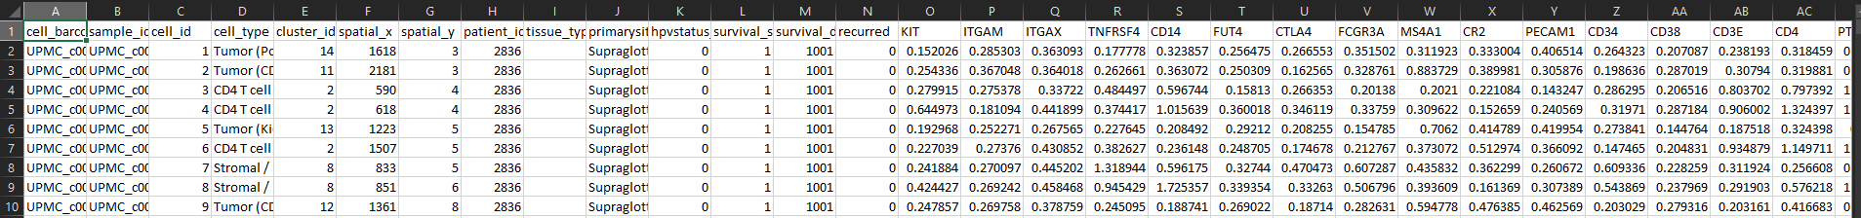
4.Output Dataset sample
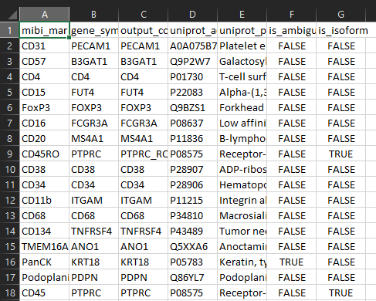
1.gene_expression_dataset.csv
2.uniprot_protein_to_gene_mapping.csv – expression matrix only
3.gene_expression_matrix.csv – expression matrix only
